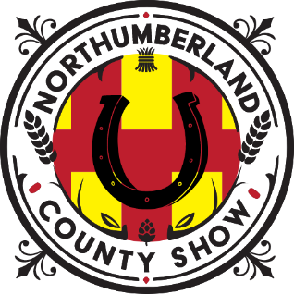
Northumberland County Show, held at Bywell, Stocksfield NE43 7AB
SATURDAY 23rd MAY 2026
FARRIERS ENTRY FORM

Judge: TBC

CLASS 1 OPEN COB SHOEING
¾ fullered on the foot and a specimen Entry Fee: £25
1st £100 2nd £50 3rd £25

CLASS 2 APPRENTICE SHOEMAKING
Pair of plain stamped bevels Entry Fee; £15
Prizes in kind
--------------------------------------------------------------------------------------------------------------------------------------
ENTRIES CLOSE ON: 19th May 2026 BACS: Sort Code: 40-24-16 Account No: 21149717 (Ref: Exhibitor Name / Farrier Comp). Northumberland County Show
Please return form to: debs.crozier@gmail.com
Telephone entries acceptable: 07793244277

Please enter me in Class _________ I have paid by BACS

Name ____________________________________________

Email address ____________________________________________

Telephone Number ____________________________________________

Signed ____________________________________________ Date ______________

