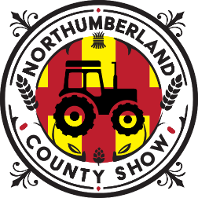
Northumberland Show
Tractors - Vintage & Modern
Show Day - Saturday 23rd May 2026

We have 3 classes; Cleanest Working Tractor, Best Restored Tractor and Most Original Tractor. The winners from each of these categories will then be entered into the Best In Show where the judge will decide the overall winner. A prize will be given for the winner of each category as well as a prize for the overall Best In Show Tractor.

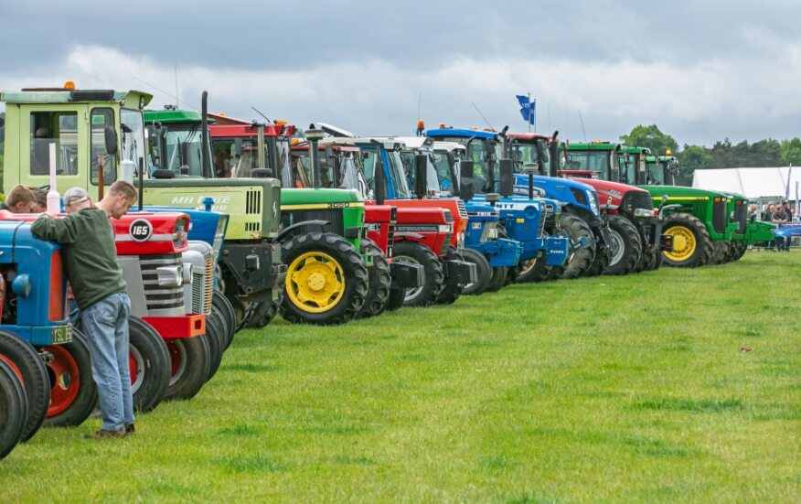
Any question or queries - email: o.walkeragricontracts@gmail.com

Northumberland Show
Tractors - Vintage & Modern
Entry Form
Tractor Details:
Make________________________________________________
Model_______________________________________________
Year _________________________________________________
Vehicle Reg: ________________________________________________
Tractors - Vintage & Modern (please indicate which class below)
Class 1: Cleanest Working Tractor
Class 2: Best Restored Tractor
Class 3: Most Original Tractor
Rosettes 1st – 3rd
Owner/Driver Details:
Name ____________________________________________________
Address: _________________________________________________________
_________________________________________________________
Postcode: ___________________________
Email Address_________________________________________________
Telephone number____________________________________________
1 entry ticket will be issued per vehicle – only with this form completed
Additional tickets can be purchased online at a discounted rate until 20th May. If you are unable to produce a valid ticket upon arrival, you will be charged full gate price of £20.
Tickets will be emailed once entries close on 20th May.
If you’d like tickets posted, please provide a self-addressed envelope and return this form to: The Show Secretary, Northumberland Show Office, Hexham Auction Mart, Tyne Green, Hexham, NE46 3SG or email Info@northcountyshow.co.uk
Or collect from the Secretary office on your arrival on 23rd May at the site)

Tractor Secretary – Mr Ollie Walker (07538991156)

Extra Information:
How many hours has the tractor got on it?

Has it had any restorations/new parts?

Our visitors are interested in the history of your vehicle, if you’d like to provide us some information for our commentator please enter below:
______________________________________________________________________________________________________________________________________________________
__________________________________________________________________________________

Any question or queries - email: o.walkeragricontracts@gmail.com

